Bài tập về nhà

Bài 2.11:

Hình ảnh code:

Test case 1:

Test case 2:

Test case 3:

Test case 4:

Test case 5:

Bài 2.12:

Hình ảnh code:

Test case 1:

Test case 2:

Test case 3:

Test case 4:

Test case 5:

Bài 2.12:

Source code:

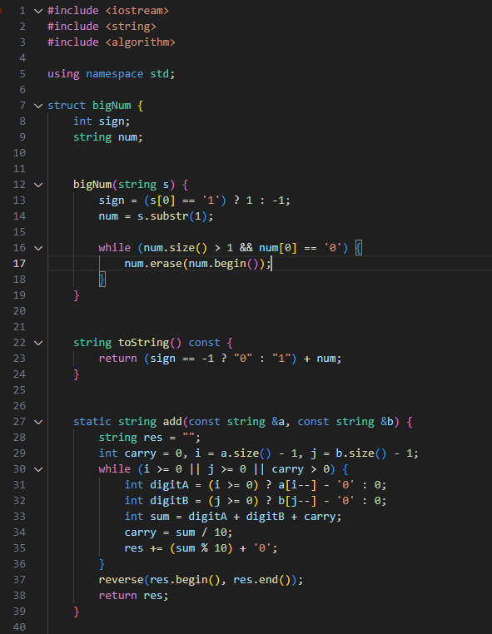

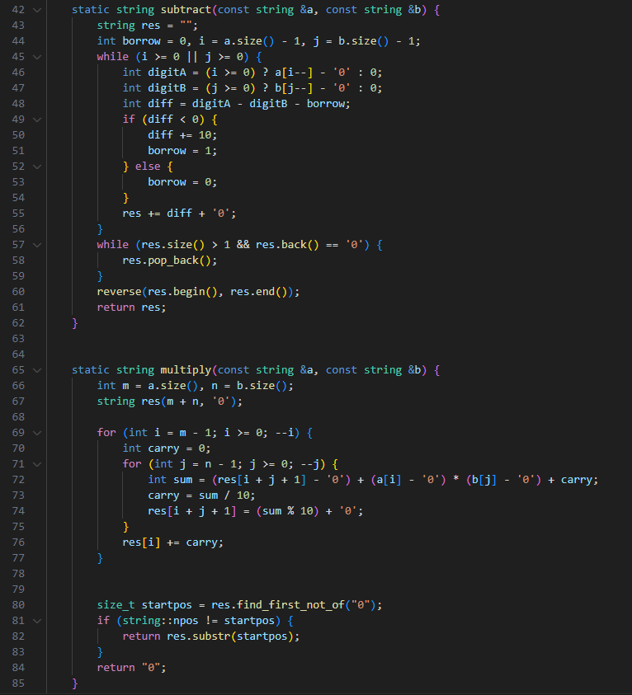

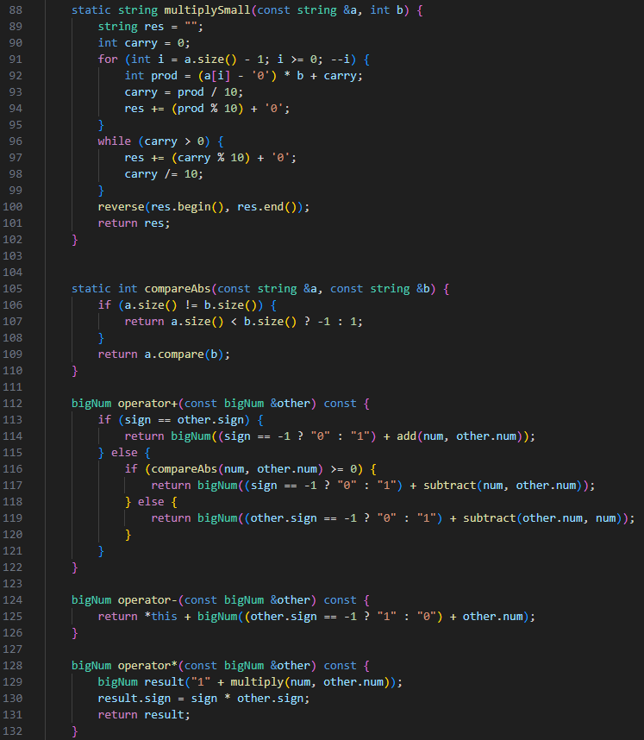

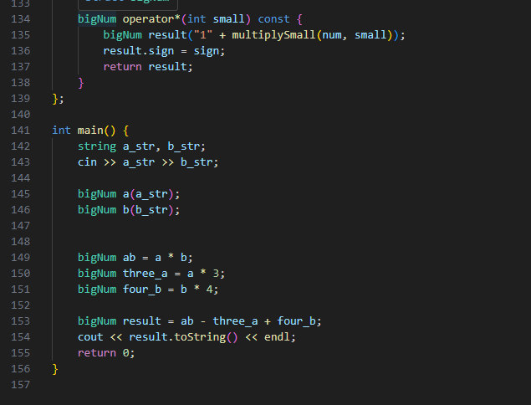

Test case 1:

Test case 2:

Test case 3:



Test case 4:

